Architecture Document

Architecture Diagram

The architecture of the proposed Digital Pharmacy Management System is designed as a microservices-based structure to enable modularity and scalability across its components. Each service, such as prescription processing, inventory management, and demand forecasting, operates independently, facilitating seamless updates and maintenance. The technology stack includes RESTful APIs for inter-service communication, with OCR integration using Python libraries like Tesseract for data extraction, and machine learning frameworks such as TensorFlow for demand forecasting. Services interact asynchronously via an event-driven architecture utilizing message brokers like RabbitMQ, ensuring real-time updates and robust data synchronization across multi-branch deployments. Centralized authentication and role-based access are managed through an identity provider, with data stored in a relational database to maintain transactional integrity. Additionally, analytical dashboards leverage business intelligence tools to visualize key metrics. This scalable, fault-tolerant architecture ensures high availability and compliance with data security and privacy standards, ultimately enhancing operational efficiency within pharmacy management.
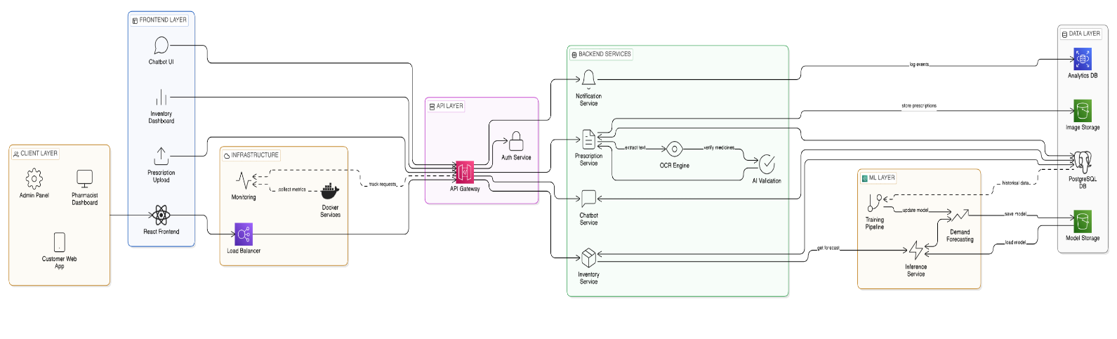

Figure 1: Architecture Diagram

ER Diagram

The ER Diagram for the Digital Pharmacy Management System encompasses key entities including Prescription, Medicine, Inventory, User, and Sales. The Prescription entity comprises attributes such as prescription ID, patient details, and medicine details, while the Medicine entity includes attributes like medicine ID, name, dosage, and expiry date. The Inventory entity maintains attributes related to stock levels and batch tracking. User entities are categorized into roles (e.g., pharmacists, administrators, and customers) with attributes for role-based access control. Relationships are established between Prescription and Medicine (many-to-many), Inventory and Medicine (one-to-many), and User and Prescription (one-to-many), maintaining cardinality to ensure data integrity. The proposed schema supports system functionalities such as automated prescription processing, inventory management, and user interaction via AI and machine learning components, facilitating task automation while ensuring data security, compliance, and operational analytics for decision support.
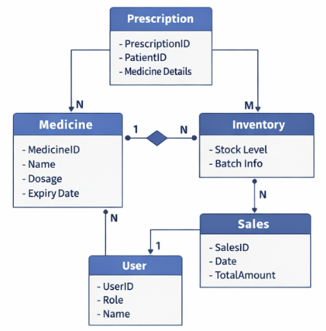

Figure 2: ER Diagram

Class Diagram

The Class Diagram for the Digital Pharmacy Management System consists of key classes such as Prescription, Inventory, User, and DemandForecast. The Prescription class, with attributes like medicineName, dosage, and quantity, includes methods for OCR extraction and AI validation. The Inventory class maintains real-time attributes for stock status, expiry dates, and batch tracking, incorporating methods to trigger low stock alerts and manage procurement. User serves as a base class, with subclasses like Pharmacist, Administrator, and Customer to implement role-based access control, ensuring security. The DemandForecast class utilizes machine learning algorithms for predictive analytics and includes associations with historical sales data. Additionally, a PharmacyChatbot class is included for user interaction, with methods for querying medication availability. The design supports modularity through encapsulation and inheritance, allowing for the extension of functionalities while ensuring compliance with security and operational requirements, ultimately facilitating seamless integration with billing modules and providing analytics through dynamic dashboards for decision-making processes.

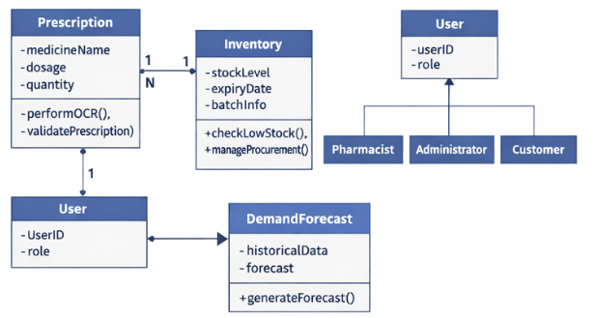
Figure 3: Class Diagram

DFD

In the Digital Pharmacy Management System, data flows from multiple input sources including scanned prescriptions utilizing Optical Character Recognition (OCR) for extracting medicine names, dosages, and quantities, as well as user interactions and sales transactions. The core processes encompass data transformation through AI-assisted validation, ensuring accuracy while updating centralized inventory and enabling automated demand forecasting. The system employs machine learning algorithms trained on historical sales data, generating forecasts that feed back into inventory management processes. Data stores consist of real-time databases that maintain stock status, expiry dates, and transactional records, accessible through secure role-based interfaces for pharmacists, administrators, and customers. Information flows seamlessly from input through processing stages, culminating in output via analytical dashboards that visualize key operational metrics; facilitating decision-making while ensuring cloud-based synchronization and compliance with data security standards and regulations necessary for protecting sensitive prescription details.
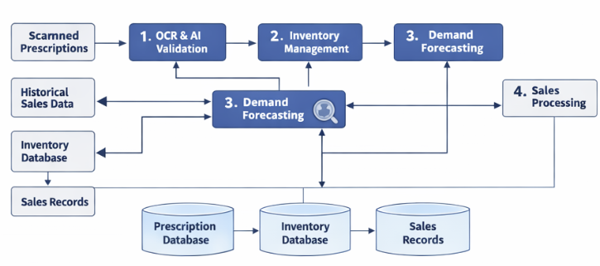
Figure 4: Data Flow Diagram

Use Case Diagram

In the Digital Pharmacy Management System use case diagram, key actors include pharmacists, administrators, customers, and the pharmacy-specific chatbot, each interacting with the system to achieve specific goals. Pharmacists manage prescriptions, verify medication details through OCR and AI validation, and handle inventory operations, including stock status and alerts. Administrators oversee user roles, ensuring secure access and compliance with privacy regulations. Customers can upload prescriptions, inquire about medication availability through the chatbot, and receive usage guidance. The system boundary encompasses integrated functionalities such as demand forecasting via machine learning, analytical dashboards for sales metrics, and automated alerts for inventory management, facilitating streamlined pharmacy operations and decision-making processes.
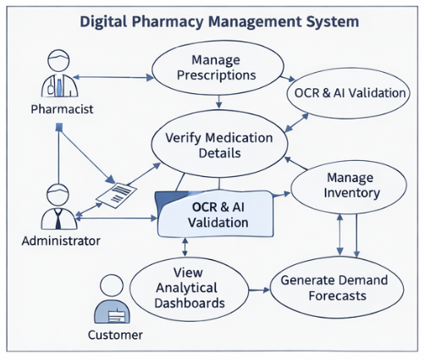
Figure 5: Use Case Diagram

Sequence Diagram

In the Sequence Diagram for the Digital Pharmacy Management System, interactions commence with the user uploading a prescription, which triggers the Optical Character Recognition (OCR) module to initiate text extraction processes, yielding medicine details for further validation. The AI validation component then assesses the extracted data, communicating discrepancies to the user while forwarding validated inputs to the centralized inventory module. Consequently, the inventory system checks stock levels and alerts pharmacists for low stock or near-expiry items, while simultaneously logging each transaction for audit purposes. Demand forecasting algorithms analyze historical sales data, providing procurement recommendations, which are conveyed to administrators. Notably, pharmacist users request real-time inventory statuses and receive responses from the pharmacy chatbot, emphasizing role-based access control throughout. As operational metrics are gathered, analytical dashboards are dynamically updated, visualizing trends and supporting decision-making processes, ensuring seamless integration with billing systems. The architecture facilitates multi-branch scalability, maintaining secure data synchronization and robust privacy measures, all while guaranteeing high system availability and fault tolerance to optimize pharmacy service delivery continually.
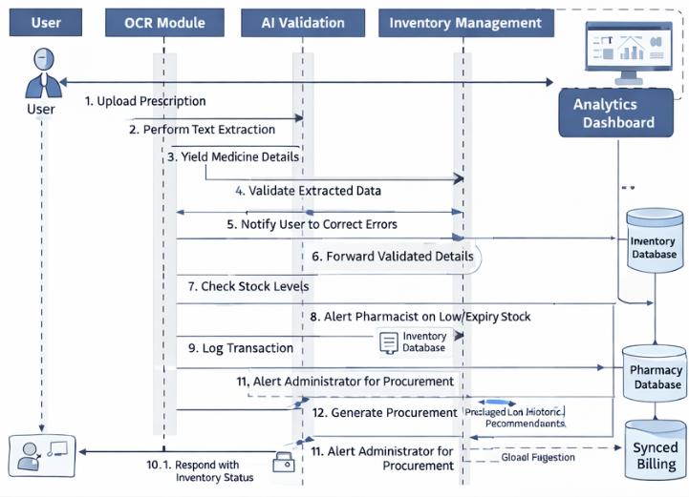

Figure 6: Sequence Diagram

Component Diagram

The Component Diagram for the Digital Pharmacy Management System delineates a modular architecture comprising distinct components such as the Prescription Processing Module, Inventory Management Module, Machine Learning Module, User Authentication Module, Chatbot Interface, and Analytics Dashboard. Each component interfaces via defined APIs, ensuring seamless data exchange and functionality integration. The Prescription Processing Module harnesses OCR technology and AI validation for accurate data extraction, feeding inputs to the Inventory Management Module, which is responsible for real-time stock auditing and automated alerts. The Machine Learning Module, trained on historical sales data, generates accurate demand forecasts and informs procurement processes, thereby interacting closely with both Inventory and Analytics components. The User Authentication Module enforces secure role-based access for pharmacists, administrators, and customers, linking to the Chatbot Interface that offers user support regarding medication availability and guidance. The Analytics Dashboard aggregates and visualizes data from all modules, providing critical insights into sales trends and operational metrics. This organized deployment architecture is further optimized for scalability across multiple pharmacy branches and incorporates cloud synchronization, ensuring data security, privacy, and compliance with regulations while maintaining high availability and fault tolerance.
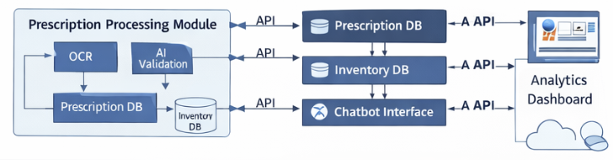

Figure 7: Component Diagram

